Name: _________________________ Narrogin Senior High School


Unit 3 Modern History

SOURCE ANALYSIS

PRACTICE PAPER

Australia 1918 - 1955

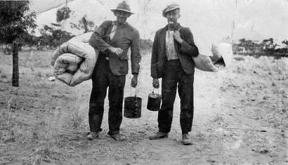

Marks out of 25:

Weighting - 5 %

SECTION ONE: SOURCE ANALYSIS SET 1, Unit 3

This section has ONE question made up of FIVE (5) parts. Attempt ALL parts. Write your answers in the spaces provided.

- The marks allocation for this section is 25 marks.

- Allow approximately 45 minutes for this section.

Indicate below the document set from the Document Booklet you will use to respond to this
question.

Set 1: □ Australia 1918–1955

Set 2: □ Russia and the Soviet Union 1914–1945

Set 3: □ China 1935–1989

Question 1

- Explain the historical context of Source 1. Include the relevant events, people and ideas depicted or represented in the source. (4 marks)

SOURCE ANALYSIS SET 1 cont…

(b) Compare and contrast the purpose of Sources 1 and 2. (5 marks)

(c) Describe the message and tone of Source 3. (3 marks)

- SOURCE ANALYSIS SET 1 cont…

(d) Identify and discuss why Sources 3 and 4 are contestable. (6 marks)

SOURCE ANALYSIS SET 1 cont…

(e) Using your knowledge of the whole period of study, evaluate the importance of the
themes, ideas and/or events represented in the four sources. (7 marks)

END OF SECTION FOUR

Question number:

Question number:

SOURCE ONE
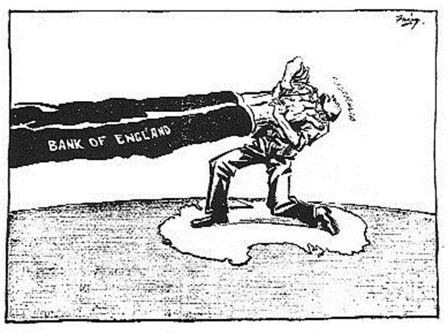

Publication unknown, circa 1930, Australian press.

SOURCE TWO

When the 12th Commonwealth parliament was opened a month later on 20 November 1929, the new government introduced a program it could not implement once the reality of economic depression unfolded. Scullin immediately ended the licensing system for waterside workers imposed by the Bruce–Page government, but this was not the time for implementing industrial relations reform. The Rothbury miners’ strike in New South Wales was a severe test of the new Labor government, as was the unemployment escalating throughout Australia.
Plummeting export income and consequent worsening of the trade imbalance had been dealt with by the Bruce–Page government by exporting gold reserves. Even before Scullin was sworn in Robert Gibson, Commonwealth Bank Chairman, had sought a meeting to advise the incoming Prime Minister of the effect of this trend given the high level of Australia’s overseas debt. It was not the collapse of the New York Stock Market in October 1929, but the burden of loan repayments due to London bankers that revealed the stark situation for Australia when parliament resumed in March 1930.

From the National Archives of Australia collection, information sourced from the Scullin ministry, folders of typed copies of Cabinet minutes, 1929–31, NAA: CP450, 1, Bundle 1/4

Source 3
During the weekend in Canberra after listening to two days of fruitless argument, I decided that the time had arrived for a showdown. Who were the real enemies of the Australian people? I was not prepared to load the blame on to the workers. They were under attack all the time. They were being blamed for the depression. Their wages were said to be too high.
Theodore and Scullin were hedging. They were not prepared to face up to Labor policy. On the one hand they were afraid of the bankers, and on the other hand did not want to antagonise the trade union movement. They were trying their hand at tight-rope walking. But their umbrellas were already exposed to the rim. The usurers were certain to win.
I always believed in the old principle that the best form of defence is attack. For six months the bankers had been on the attack. Theodore was no more anxious for a showdown than Lyons. I realised that if someone did not put up a fight we would all go down, and with us the Australian economy.
The Birth of the Lang Plan, Jack Lang.

Source 4

